** Matthew G. Moffett**

**Experienced Evaluation • Efficient Strategy • Excellent Resolution**

Gray Rust St. Amand Moffett Brieske LLP

1700 Atlanta Plaza

950 East Paces Ferry Road

Atlanta, Georgia 30326

Direct Line: (404) 870-7390

Cell: (404) 229-7899

Facsimile: (404) 870-1030

Email: [mmofett@grsmb.com](mailto:mmofett@grsmb.com)

Website: [www.grsmb.com](http://www.grsmb.com)

Matt Moffett secures the best possible results for his corporate and insurance clients and is recognized annually as one of the Top 100 lawyers in Georgia. He recently tried and won four wrongful death cases where each plaintiff attorney asked the jury for a 7 figure verdict. He further secured a defense verdict for his corporate client in a sexual assault case where the plaintiff attorney asked the jury for a million dollars. And last year, following an 8 figure demand and during the trial of a spinal cord injury case, he convinced the plaintiff attorney to settle for a 5 figure number. Matt has tried over 150 cases successfully in state and federal courts.

Matt is a member of the executive committee of the Georgia Defense Lawyers Association, and he is an instructor at the GDLA Trial Academy. He regularly speaks all over the country to lawyers, risk managers and claims professionals and has presented often for the Defense Research Institute and the Claims and Litigation Management Alliance.









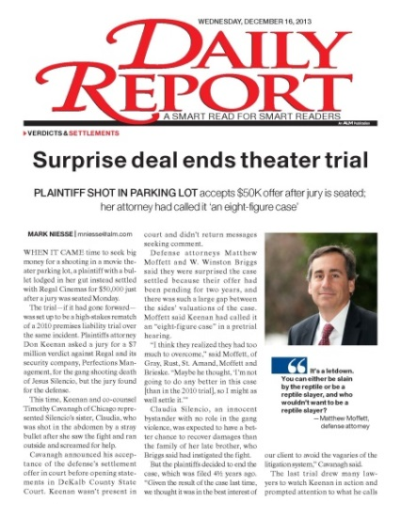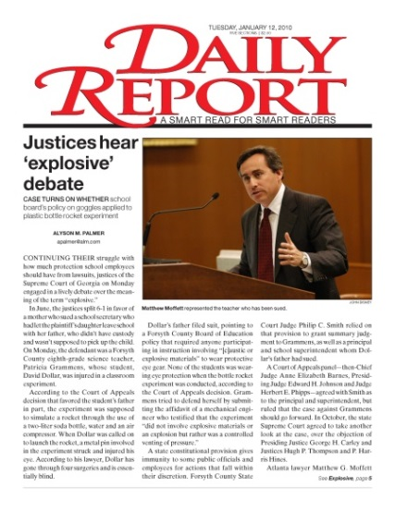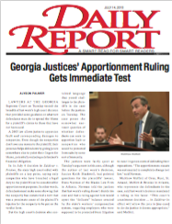

   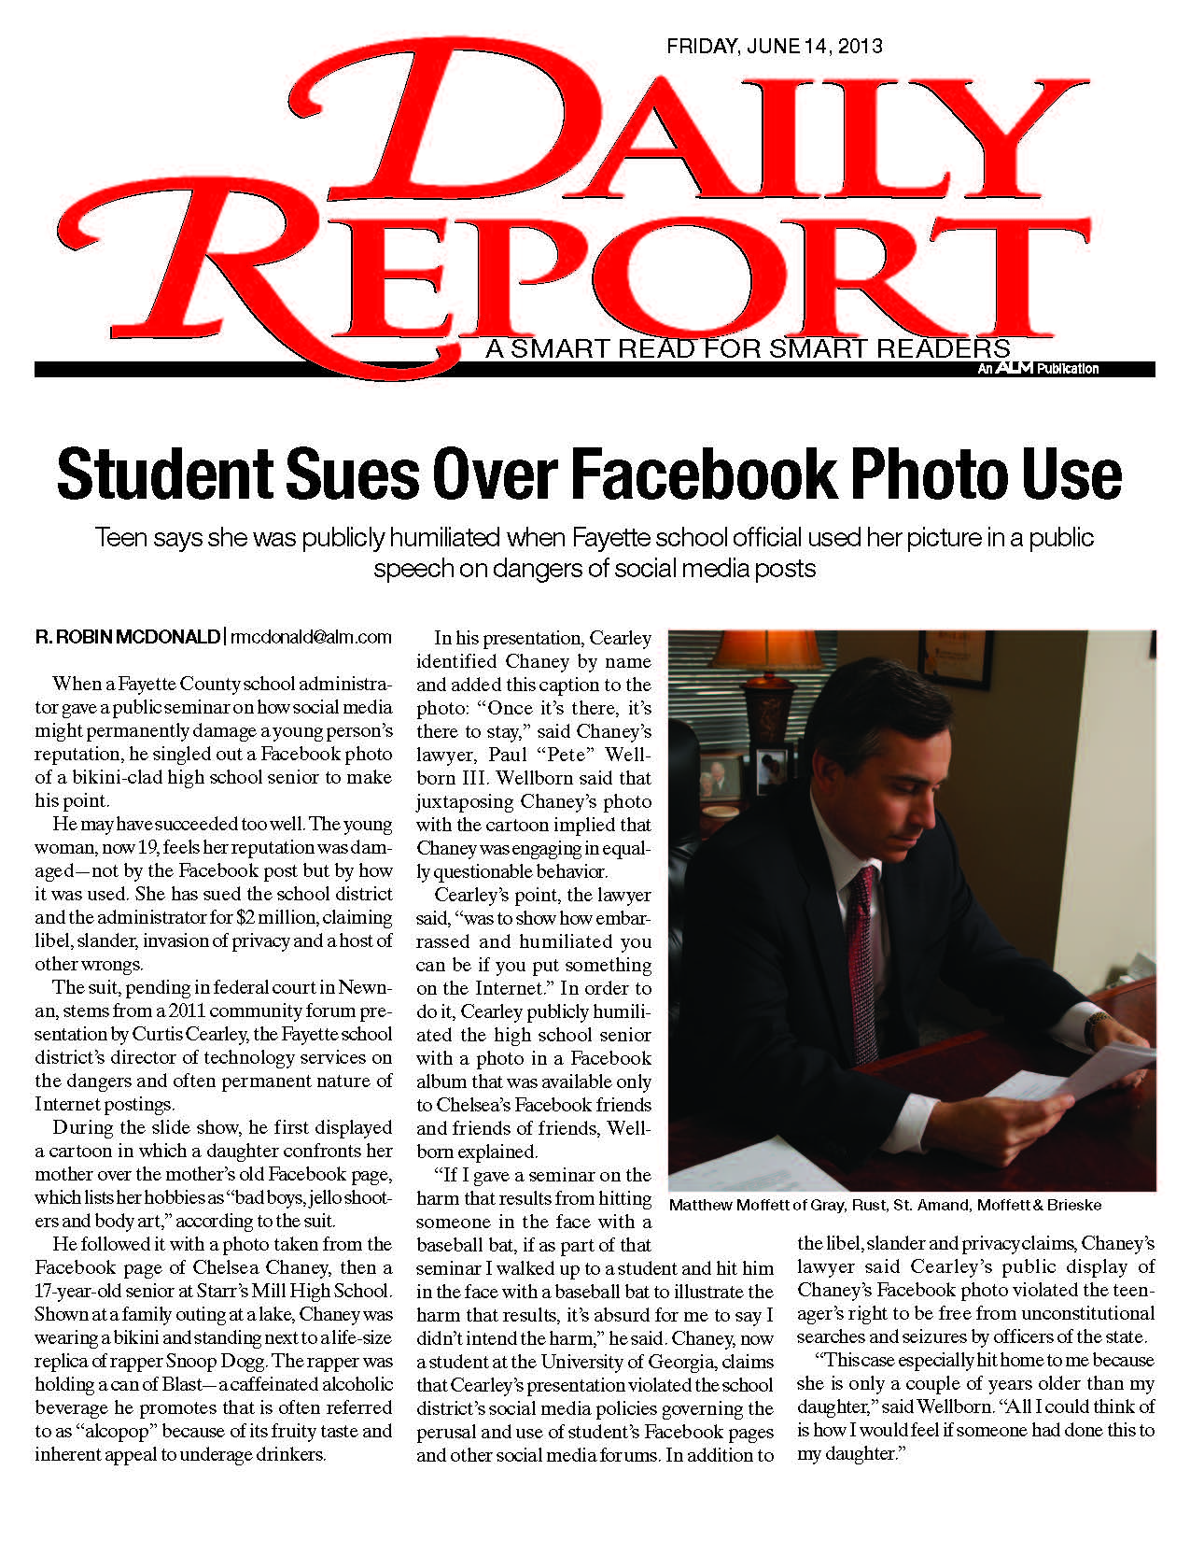

Gray • Rust • St. Amand • Moffett • Brieske, LLP

Significant Defense Trial Verdicts

***Pacheco v. Regal Theater and Perfections Security***

***State Court of DeKalb County, 08A99832-1***

Negligent security, third party criminal attack, wrongful death. Two week trial involving multiple medical, pathology, criminology, security and economist experts, concerning shooting and death of a patron in a movie theatre. 7 figure settlement demand. Defense verdict.

***Dibble v. Riggins and RUMC***

***State Court of Fulton County, 06-EV-0101181D***

Sexual assault/molestation, negligent hiring/supervision/retention. One week trial in defense of religious institution sued over 16 year old allegedly seduced, if not forced into sexual relationship with youth minister. 7 figure settlement demand. Defense verdict.

***Vasilieva v. Crowe***

***State Court of Fulton County, 06EV001256E***

Pedestrian/vehicle wrongful death. 7 figure settlement demand. One week trial involving accident re-construction, traffic engineering, human factors, economist and multiple medical experts. Confidential hi-lo agreement in place. Defense verdict.

***McDowell v. Optimus Solutions, LLC***

***State Court of Cherokee County, 07-SC-1741***

Vehicle collision, spinal surgery. One week trial in defense of corporation whose driver was cited by investigating officer for improper left turn as cause of serious injury collision. 6 figure settlement demand. Defense verdict.

***Raines v. Maughan***

***State Court of Fulton County, 2007EV001852A***

Premises liability, third party criminal attack, wrongful death. One week trial in defense of an apartment complex sued by mother of individual shot and killed on property. 7 figure settlement demand. Defense verdict.

***Godbee/Chick v. KIA and Leverette***

***State Court of Cobb County, 2007A-12496-3***

Vehicle collision, product defect, wrongful death. Two week trial involving accident reconstruction, biomechanical engineering, design engineering, human factors, medical and economist experts, concerning driver involved in low speed collision resulting in airbag deployment causing rupture to driver’s aorta and resulting death. 7 figure settlement demand. Defense verdict.

**Read Matt’s blogs online at** [**www.grsmb.com/moffett**](http://www.grsmb.com/moffett)

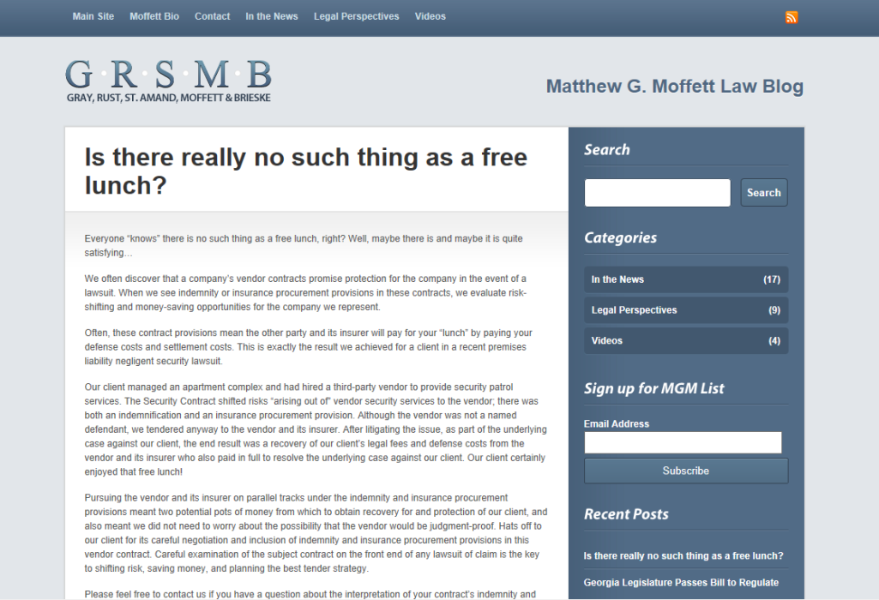

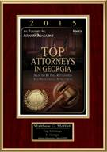

**One of the Best!**

“Matt is simply one of the best civil defense lawyers I know (and I have worked against some really good ones around the county). If you are a defendant or an insurer, you would be well served with Matt in your corner. If you are a plaintiff or plaintiff’s lawyer, don’t underestimate this guy!”

-Nationally Recognized Trial Attorney with $250+ million in recoveries – Serious Injury/Wrongful Death Cases Nationwide.

**Professionalism and Skill**

“Matt, I wanted to pass along my congratulations to you for the result on this case and the appreciation of our insured. I have shared a letter sent to me from the insured with our management here. It expresses appreciation for the professionalism and skill demonstrated by all involved in the case, including the legal representation your firm provided. Thank you for your efforts as our panel counsel.”

-Claims Supervisor for National Insurer

**Honest and Straightforward**

“Matt Moffett is an honest and straightforward lawyer with excellent trial skills. He is highly regarded by his professional colleagues.”

-Adverse Counsel Testimonial

**Vindication**

“I want to thank you for all your hard work and the great job you did preparing and trying the case . . . and several colleagues asked me to pass along their respects for a job well done. I just got off the phone with the insured and he couldn’t say enough . . . his wife used words like “superb” and “fantastic”, and said that she couldn’t have handpicked better attorneys. They both felt a great sense of relief getting with they called vindication. I think this will help them move on after almost five years. Thanks again for your hard work”

-Claims Examiner for National Insurer